
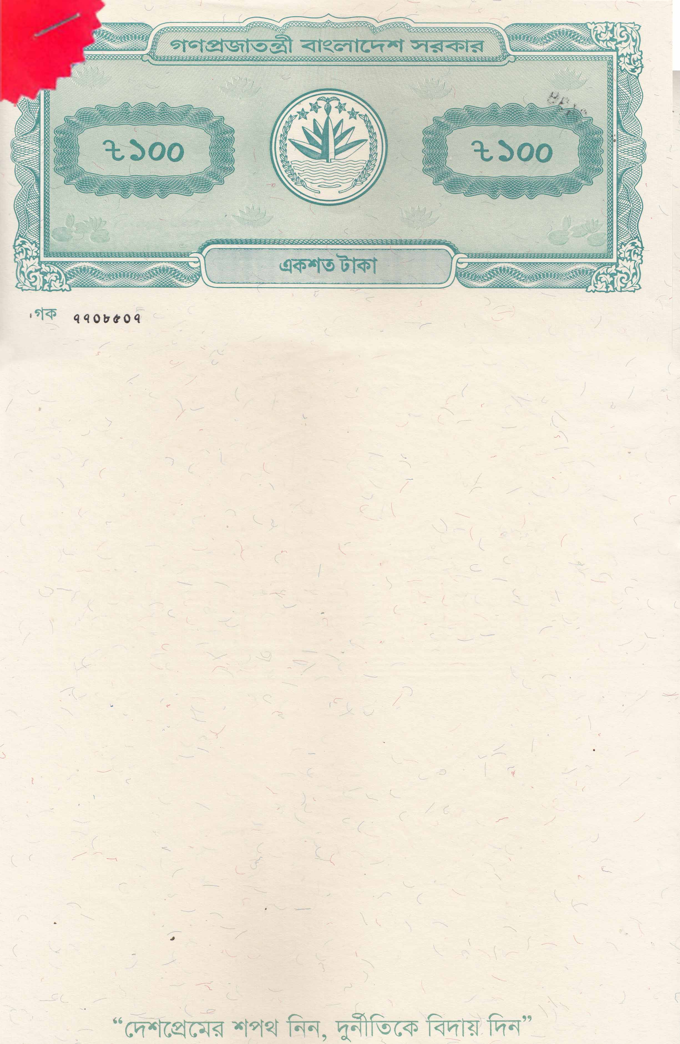
BEFORE THE NOTARY PUBLIC DHAKA, BANGLADESH
AFFIDAVIT OF FINANCIAL SUPPORT
IN FAVOR OF
MATHEW MICKEY COSTA
FOR HIGHER STUDY IN Australia
I, Mary Margaret Costa, Father’s Name: Michael Rosario, Mother’s Name: Cecilia Rodrigues, Permanent Address: House/Holding: 16/C, Village/Road: East Rajabazar, Post Office: Tejgaon - 1215, Tejgaon, Dhaka North City Corporation, Dhaka. Nationality: Bangladeshi, National ID Card No- 8227341917, Religion: Christian, Profession: Business, do hereby solemnly affirm and declare the following that:

- I am the lawful Mother and sole financial sponsor of MATHEW MICKEY COSTA, who has been accepted to pursue higher education in the Master of Professional Accounting Advanced at University of Wollongong (UOW), Australia.
- I undertake full financial responsibility for his academic, living, travel, insurance, and incidental expenses throughout the entire duration of his studies in Australia.
- I possess sufficient financial resources to support my son's education and stay abroad, and I have demonstrated my liquid funds and financial capacity as demonstrated below.
- These funds originate from my legitimate personal income and savings. I am financially sound and solvent, as verified by my bank, and capable of fulfilling all sponsorship commitments.
- I further undertake to ensure MATHEW MICKEY COSTA completes his full-time academic program as intended and returns to Bangladesh upon the completion of his studies.

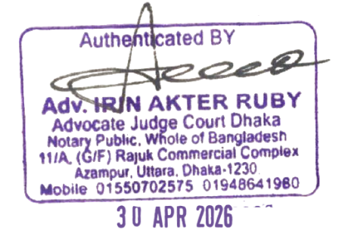
Fund Details:
Fund Details | Amount in BDT | Amount in AUD
Account Name: MARY MARGARET COSTA  Bank Name: Pubali Bank PLC  Account Type: FDR  Account Number: 2966104037677  Fund Origin date: 01/01/2025 | 8,000,000.00 | 90,548.95
Total Available Funds | 8,000,000.00 | 90,548.95
Source of Fund:

Accumulated Savings from Business

(N.B: Rate: BDT 88.35 per AUD as on 30.04.2026)


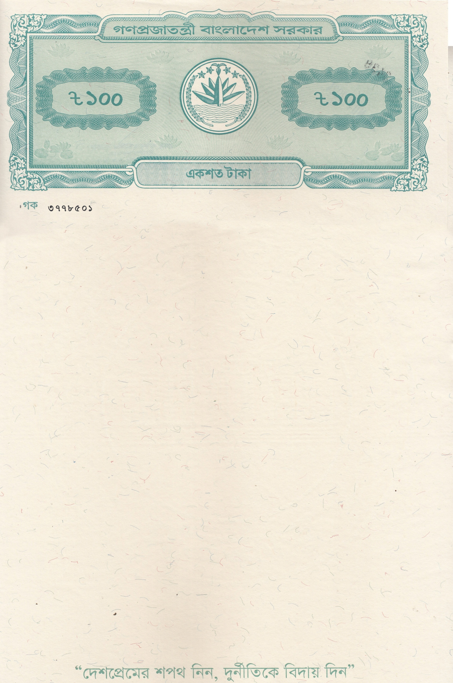
The Above Stated Funds Came from My Accumulated Income Through the Sources Detailed Below:

Income Details | Annual Income in AUD
Sponsor Name: MARY MARGARET COSTA  Income Source: Business  Business Type: Wholesaler & Retailer of Readymade Garments  Monthly: BDT 240,000.00 | 32,597.62
Sponsor Name: MARY MARGARET COSTA  Income Source: Rent  Rent Type: Shop Rent  Monthly: BDT 120,000.00 | 16,298.81
Total Annual Income | 48,896.43


Immoveable Asset Details:
Sl. No | PARTICULARS of LAND/PROPERTY: | Present Market Value in BDT  (approximately) | Present Market Value in AUD  (approximately)
a) | I am the owner of a residential building named "ACME MOKBUL VILLA," consisting of 9 (nine) floors, built according to the Rajuk-approved design, located on 350 square yards or 0.0722 acres of land. District-Dhaka, Police Station, and Sub-Registry Office Pallabi. Mouza: Uttar Senpara Parbata, Section-12, Block-A, Road No. 05, Plot/House No. 96 (ninety-six). | 22,500,000.00 | 254,668.93
b) | I am the owner of land measuring 13.94 Kathas or 6.50 decimal, there stands a 7 (seven) storied commercial building. Out of the total land, an undivided and un-demarcated proportionate share of 0.656 Katha or 1.083 decimal (out of 6.50 decimal) together with the entire portion of the 7th floor measuring 1,800 square feet. | 19,000,000.00 | 215,053.76
Total Property Value: |  | 41,500,000.00 | 469,722.69
(N.B: Rate: BDT 88.35 per AUD as on 30.04.2026)
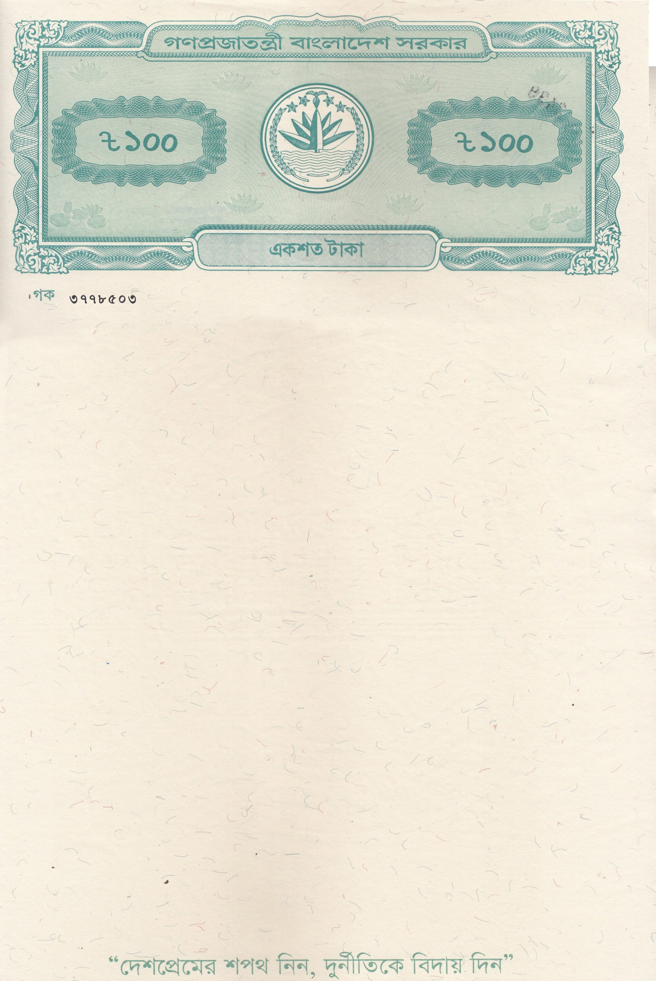


I solemnly affirm that all the above statements are true and correct to the best of my knowledge and belief. In witness whereof, I have executed this Affidavit of Financial Support before the Notary Public in Dhaka, Bangladesh, on this date.

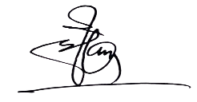

MARY MARGARET COSTA
(Signatures of Deponents)

The deponent is personally known to me, has been duly identified, and has signed this affidavit in my presence.


